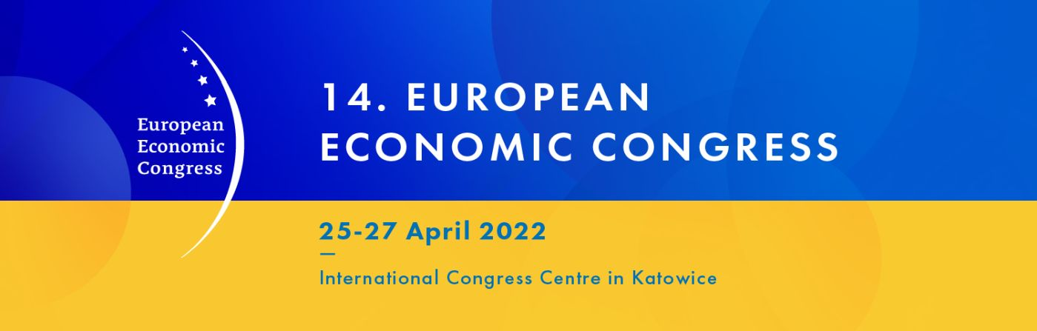

The European Economic Congress with a new mission for Ukraine
#StandforUkraine

The events of recent days – the Russian aggression against Ukraine – have shaken Europe and the world. We cannot predict what will happen next, but we know that our Europe will not be the same after what has happened. The plans for this year’s edition of the European Economic Congress are undergoing a fundamental change in order to respond to the greatest challenge for Europe, its people and its economy in decades.

Condemnation of the aggression and a declaration of support for actions that can halt the dramatic course of events and help Ukraine and the Ukrainians at the critical moment in their history are now part of the new mission of the European Economic Congress. Seen from this perspective, the situation in Ukraine requires proper analysis and implementation of real aid activities, both during and after the war.

We have decided to modify this year’s agenda. The support for Ukraine, the future scenarios, and specific proposals for action will all be directly reflected in the programme, thus becoming the mainstream of the Congress. We are establishing co-operation with the circles, institutions and individuals supporting Ukraine at this difficult time. We want to join the broad movement of support for Ukraine with all our experience and knowledge, using the technical and organisational possibilities and instruments provided by a significant media group operating in the Polish market and specialising in important economic areas.

We have not for a second doubted that the European Economic Congress circles share our sentiments and declare their willingness to act.

We therefore encourage everyone – entrepreneurs, investors, companies related to Ukraine in various ways, young Polish business, economic organisations, local authorities, experts, and advisers – to share with us their ideas on how to effectively help Ukraine – here, in our common Europe, and now – in the coming weeks, which will perhaps be the toughest ones. We remain open to all suggestions, which can be made by filling in the form available at: www.eecpoland.eu.

Through our words, attitudes and facts, let us urge decision-makers in the region, across Europe and worldwide to use extraordinary measures in order to exert decisive pressure on the aggressor as soon as possible. Our aim is not only to give the support for Ukraine its rightful place on the agenda of this year’s Congress, but also to bring about action that will be a real help – now and in the future. We want to stimulate representatives of all levels of state and local administration to take the right steps and enable them to engage in dialogue – among themselves as well as with all the parties concerned.

We declare our commitment here and now – but also in the long term – by including the support for Ukraine in the mission of the Congress. We are looking forward to co-operating with you and we are counting on you to be especially active at this exceptional time. With a view to being effective and meeting real needs, we will co-operate with those who implement such activities using their many years of experience.

